 | | Process Definition  Document
Cookie clicker Automation

Our solution automates the popular game “Cookie Clicker”. It tries to ease the tasks of the player, by continuously clicking on cookies, prioritizing purchasing upgrades and buildings to maximize the cookie production. At fixed intervals, the script generates a progress report detailing cookie counts and the overall performance, i.e. cookies generated per second. The user receives the report via email.

Contents
1. Introduction 1
1.1 Purpose 2
1.2 Objectives 2
1.3 Key Contacts 2
1.4 Minimum Pre-requisites for the Automation 2
2. AS IS Process Description 2
2.1 Process Overview 3
2.2 Applications Used 3
2.3 AS IS Process Map 4
2.3.1 High Level Process Map 4
2.3.2 Detailed Level Process Map 4
2.4 Process Statistics 4
2.5 Detailed AS IS Process Actions 5
2.6 Input Data Description 5
3 TO BE Process Description 6
3.1 Detailed TO BE Process Map 6
3.2 Parallel Initiatives 6
3.3 In Scope for RPA 6
3.4 Out of Scope for RPA 6
3.5 Exception Handling 7
3.5.1 Known Business Exceptions 7
3.5.2 Unknown Business Exceptions 7
3.6 Applications Errors & Exceptions Handling 7
3.6.1 Known Applications Errors and Exceptions 8
3.5.2 Unknown Applications Errors and Exceptions 8
3.7 Reporting 8
4 Other 8
4.1 Additional sources of process documentation 8

Introduction

1.1 Purpose
Our solution automates the popular game “Cookie Clicker”, in order to ease the task of the player, and be efficient as possible when talking to about buying new upgrades

1.2 Objectives
The business objectives and benefits expected by the Business Process Owner after automation of the Cookie Clicker are:
- Waste no time before doing the upgrades
- Enable exponential more clicks on the cookies
- Give the user the necessary reports to draw a conclusion on his progress

1.3 Key Contacts
Add here any stakeholders that need to be informed or to approve changes to the process:
Role | Name | Contact Details (email, phone number) | Notes
developer | Ichim Vlad
developer | Kalman Horatiu
developer | Manea Robert
developer | Jorza Ionut

1.4 Minimum Pre-requisites for the Automation
- Credentials (user ID and password) required to logon to email server

AS IS Process Description

2.1 Process Overview

Item | Description/Answer
Process Full Name | Cookie Clicker Automation
Process Area | Games and Leisure
Department | Game
Short Description  (operation, activity, outcome) | Our solution automates the popular game “Cookie Clicker”. It tries to ease the tasks of the player, by continuously clicking on cookies, prioritizing purchasing upgrades and buildings to maximize the cookie production. At fixed intervals, the script generates a progress report detailing cookie counts and the overall performance, i.e. cookies generated per second. The user receives the report via email
Role(s) required in applications to perform the process | n/a
Process schedule and frequency | On user request
Number of times the process is ran by selected frequency | One time
Process execution time | >= 10seconds
Process Restrictions | n/a
Peak Period (s) | Friday evenings
Peak Volume Approximate increase | 50% increase in reference to business days
Number of persons performing the process | 1
Expected Volume increase during next periods | n/a
Percentage Un-handled exceptions | 25%
Input data description | The input asked from the user is the email he wants to send the report to
Output Data description | The output includes a report of the user’s progress gained while

2.2 Applications Used
The table includes a comprehensive list of all the applications that are used as part of the process to be automated to perform the given actions in the flow.
Application Name | Version | Application Language | Thin/Think Client | Environment/ Access method | Comments
Google Chrome | Version 131.0.6778.265 | English | Thin Client | Desktop Application | Used to run the game and register progress
Gmail SMTP Server | N/A | N/A | N/A | supporting infrastructure | Sending progress reports via email

2.3 AS IS Process Map

2.3.1 High Level Process Map

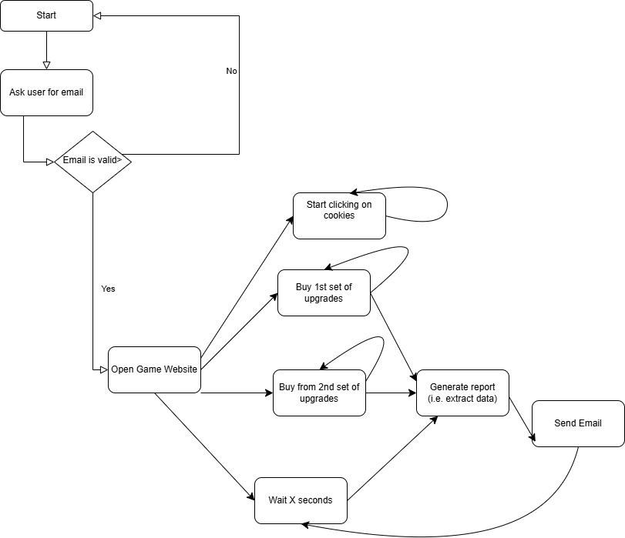2.3.2 Detailed Level Process Map

- Provide the user email address
  - The user is prompted to provide an email address via a form or input dialog.
  - The provided email address is validated to ensure it is in a correct format (e.g., using regex).
  - The validated email address is stored in a variable for use in report generation and email activities.
- Open the browser and navigate to the Cookie Clicker website.
  - Launch the browser (e.g., Google Chrome).
  - Navigate to the Cookie Clicker website URL (e.g., https://orteil.dashnet.org/cookieclicker/).
  - Wait for the page to load completely.
- Begin clicking the cookie to generate cookies.
  - Locate the clickable cookie element on the webpage.
  - Perform repeated clicks using automated mouse click activities (e.g., Click in UiPath).
  - Continue clicking until a predefined condition is met, such as a specific number of cookies being generated.
- Monitor available upgrades and click them to improve cookie generation.
  - Check the upgrades section on the webpage for items that can be purchased.
  - Evaluate upgrades based on affordability (number of cookies available vs. upgrade cost).
  - Perform clicks on the purchasable upgrades to apply them.
- Repeat steps 2 and 3 until progress goals are met.
  - Loop through steps 3 (clicking the cookie) and 4 (purchasing upgrades).
- Periodically note cookies generated per second (CPS) for manual tracking.
  - Extract the CPS value from the game interface using text recognition activities
  - Store the CPS value in a variable for use in reports.
  - Log the CPS value periodically to a file and send it via email.

2.4 Process Statistics
High Level statistics
Processes | Windows |  | Actions | Mouse clicks | Keys pressed | Text entries | Hotkeys used | Time
{total_applications_count} | {total_windows_count} | {total_actions_count} |  | {total_clicks} | {total_keys_pressed} | {total_text_entries} | {total_hotkeys} | {process_execution_time}
2 | 1 | 77 |  | >=100 per second | 0 | 1 | 0 | indefinitely

Detailed statistics
Window name | Mouse clicks | Text entries | Key pressed
{#windows}{name} | {total_clicks} | {total_text_entries} | {total_keys_pressed} {/windows}
Google Chrome | >=100 per second | 1 | 0
Email client | 1 | 2 | 0

2.5 Detailed AS IS Process Actions
#Action | Input | Description | Details (Screen/Video Recording Index | Exception Handling | Possible Actions
1 | User email address | Prompt user to provide an email address | User input screen  Screen 1 | Validate email format (regex); | Ask again for the email
2 | URL (https://cookieclicker.com) | Open browser and navigate to Cookie Clicker game | Browser window showing the game  Screen 2 | Handle browser launch errors or page load failures | Show error message to user and retry
3 | Clickable cookie element | Click the cookie repeatedly to generate cookies | Screen 2 | N/A | N/A
4 |  | Check for available upgrades to purchase | Screen 2  Upgrades section of the game | Handle cases where upgrades are unavailable  (can’t be clicked) | Log to console and skip the element
  Cookies count, game state
5 | CPS value from game interface | Extract and log cookies per second (CPS) | Screen 2  CPS display on game UI | N/A | N/A
6 | Email from user input | Compose and send an email with the generated report | N/A | N/A | 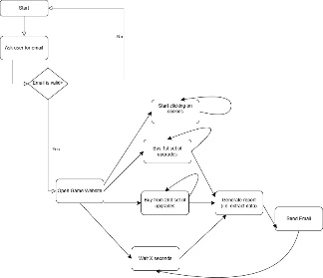N/A

2.6 Input Data Description
The following table should contain details regarding the inputs that every action of the process takes.
#Action | Sample | Input Type | Location | Are inputs Natively Digital*? | Are the inputs Structured*?
Ask for the email | andrei@gmail.com | User input | Input dialog | no | no
Open the browser and navigate to the Cookie Clicker website. | https://orteil.dashnet.org/cookieclicker/ | Mouse action | Website | Yes | no
Begin Clicking the Cookie to Generate Cookies And buy upgrades | Cookies count (game state) | Dynamic number | Website | Yes | no
Record performance | total cookies generated | Numeric | File | yes | yes
Send Email | Subject: "Cookie clicker generated Report” | Email message | Email client | Yes | no
Repeat Process |  | process step | application | yes | no

TO BE Process Description
In this section the proposed improvements to the process, actions to the process will be outlined as well as the actions proposed for automation and the type of robot required. This will be cross-checked by the Solution Architect.

3.1 Detailed TO BE Process Map
A detailed process map of the process as it will look like post-automation will be outlined here.
Highlight Bot interventions/ To-Be automated actions with different legend/ icon (purple).
Mention below if process improvements were performed on the To-Be design and provide details.
Legend | Description
 | Action number in the process. Referred to in details or Exceptions and Errors table.
 | This process action is proposed for automation.
 | This process action remains manual (to be performed by a human agent).

Action | Description | Legend
1 | The user is prompted to input their email address through a form or input dialog. The email is then validated to ensure it follows the correct format, typically using regex. Once validated, the email address is stored in a variable for future use, such as for generating and sending progress reports. Proper error handling is incorporated to display a meaningful message if the email format is incorrect.
2 | The user launches a web browser, such as Google Chrome, and navigates to the Cookie Clicker game website (e.g., https://orteil.dashnet.org/cookieclicker/). The browser waits for the webpage to load completely, ensuring the game is accessible.
3 | Once the website is loaded, the user starts clicking the main cookie to generate cookies. The automation identifies the clickable cookie element on the webpage and repeatedly clicks it using automated mouse-click activities.
4 | he automation then checks the available upgrades within the game to identify those that can be purchased to enhance cookie generation. Based on the number of cookies available and the cost of each upgrade, the automation clicks on the affordable upgrades to apply them. The goal is to prioritize upgrades that provide the highest increase in cookies per second (CPS).
5 | At regular intervals, the automation notes the cookies generated per second (CPS) by extracting this value from the game interface using text recognition or OCR activities. The CPS value is stored in a variable and logged for future reporting. This CPS data is also periodically sent via email or logged to a file, with timestamps for better tracking and analysis.

3.2 Parallel Initiatives
The table below will capture the proposed Business, Process or Application changes to be made in the near future that would impact the process at hand (if any).
Initiative Name | Process Action(s) where it is identified | Impact on current Automation Request | Expected Completion Date | Contact Person
UI Automation | Navigate to cookie clicker, start the game, and start clicking | Reduced user intervention, the user can also help the robot play the game, by extra clicks | n/a | n/a
Sending reports via email | Generate the report and send an email | Data mining and reduced manual interaction | Every X seconds | n/a

3.3 In Scope for RPA
All steps in the process, from opening the browser, doing the upgrades, extracting data, generating reports and sending emails, are automated.

3.4 Out of Scope for RPA
Besides the asked information about the user email, there are no activities or actions outside the scope of RPA. All steps in the process, from opening the browser, doing the upgrades, extracting data, generating reports and sending emails, are automated.
Activity/Action* | Reason for out of scope | Impact on the TO BE | Possible measures to be taken into consideration for future automation
Action 1 | Input is handwritten | After the user writes his email no action is required | N/A
*Add more rows to the table to reflect the complete documentation provided to support the RPA process.

3.5 Exception Handling
The Business Process Owner and Business Analysts are expected to document below all the business exceptions identified in the automation process. Exceptions are of 2 types and both need to be addressed:
Known exceptions = previously encountered. A scenario is defined with clear actions and workarounds for each case.
Unknown = New situation that was not encountered before. It cannot be predicted and in case it happens it needs to be flagged and communicated to an authorized person for evaluation.

3.5.1 Known Business Exceptions
Details regarding how the robot should handle the exceptions.
Exception Name | Scenario | Actions to be taken
BusinessRuleException | The upgrade can’t be bought | Log the denied upgrade and continue to retry the next upgrades
CustomException | The user provides an invalid email | Inform the user and ask for new input

3.5.2 Unknown Business Exceptions
An umbrella rule that includes a notification needs to be designed for all other exceptions that could happen and cannot be anticipated.

Exception Name | Scenario | Actions to be taken
Website Not Working | The website is not accessible or not working | Log the error, notify the responsible team, and proceed to the next transaction

3.6 Applications Errors & Exceptions Handling
A comprehensive list of all errors, warnings or notifications should be consolidated here together with the action to be taken for each by the Robot. There are 2 types of exceptions/errors:
Known = Previously encountered and action plan or workaround available for it (e.g. SAP unresponsive during peak times)
Unknown = these are exceptions and errors that cannot be anticipated but for which the robot needs to have a rule so that the RPA solution is sustainable.

3.6.1 Known Applications Errors and Exceptions
Details regarding how the robot should handle the exceptions.
Error/Exception Name | Action | Parameters | Actions to be taken
Email Server not responding | Wait a time and try again | Error message | retry

3.5.2 Unknown Applications Errors and Exceptions
An umbrella rule that includes a notification needs to be designed for all other exceptions that could happen and cannot be anticipated.

3.7 Reporting
In this section all the reporting requirements of the business should be detailed so that when the RPA solution is moved to production the administrators can track the performance of the solution.
Report Type | Update frequency | Details | Monitoring Tool to visualize the data
Progress Report | Daily | The progress report will track the total number of cookies generated, the cookies per second (CPS), the upgrades purchased, | Tableau

